Australian Islamic College 2018

ATAR Chemistry Units 3 and 4

Task 10 (Weighting: 5%)

Amino Acids and Proteins Validation Test

Test Time: 25 minutes

Please do not turn this page until instructed to do so.

First Name | Surname

Teacher

Mark / 23 | Percentage

Equipment allowed: Pens, pencils, erasers, whiteout, rulers and non-programmable calculators permitted by the Schools Curriculum and Standards Authority.

- This question refers to the diagram below that shows four types of side chain interactions maintaining the tertiary structure of a protein. [8 marks, 1 each]

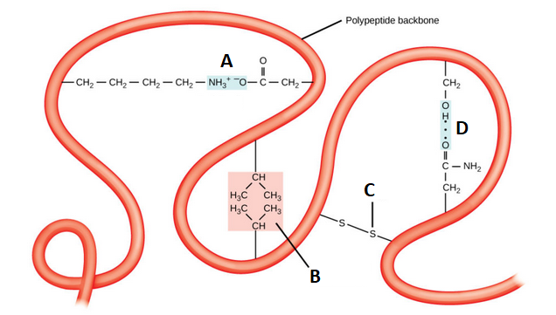

- Name the following labelled side chain interactions seen on the diagram.

A ______________________________________________

B ______________________________________________

C ______________________________________________

D ______________________________________________

- Which side chain interaction (A, B, C or D) is maintained by a covalent bond?

- Which side chain interaction (A, B, C or D) involves cysteine residues?

- Which side chain interaction is typically found in the centre of a globular protein?

- Which type of side chain interaction (A, B, C or D) also maintains the secondary structure of a protein?

- Which of these amino acids is least likely to be found in the hydrophobic core of a protein? Circle the correct answer. [1 mark]
  - Glycine
  - Tyrosine
  - Isoleucine
  - Proline

- This question refers to this diagram showing part of the structure of a protein.
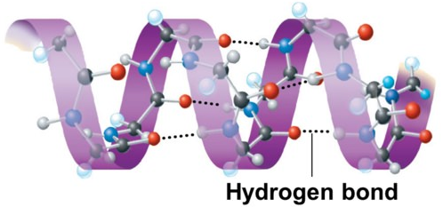
  - Name the type of secondary structure represented by this diagram. [1 mark]

  - Which of these pairs of amino acids is most likely to be involved in maintaining the type of secondary structure seen in this diagram? Circle the correct answer. [1 mark]

    - Serine – asparagine
    - Alanine – methionine
    - Cysteine – proline
    - Lysine – glutamic acid

- Draw the amino acid alanine as it exists in neutral solution i.e. draw the zwitterion form of the amino acid alanine. Show all atoms and all bonds. [1 mark]

- Draw the chemical structure, showing all bonds and all atoms, of the amino acid glycine as it would exist in solution at pH=1. [1 mark]

- Bradykinin is a short peptide that lowers blood pressure. The primary structure of bradykinin is shown in diagram 1.

Arg-Pro-Pro-Gly-Phe-Ser-Pro-Phe-Arg

Diagram 1

A short section of a bradykinin molecule is shown in Diagram 2.

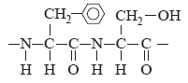

Diagram 2

On diagram 1 circle the section of bradykinin that is shown in diagram 2. [1 mark]

- Peptides can be completely hydrolysed to their component amino acids by treatment with 6M HCl. Name the two functional groups that are formed as a result of the hydrolysis of the peptide link. [2 marks]

- Name the functional group on the end of the side chain of serine. [1 mark]

- Enzymes are important proteins. Invertase is an enzyme which catalyses the conversion of sucrose to glucose and fructose. Invertase has a maximum activity temperature different from many other enzymes. The graph below shows the results of a study into the effects of both pH and temperature on the activity of invertase in sucrose solution.

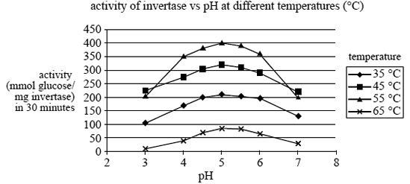

  - At what temperature and pH does invertase have maximum activity? [2 marks]

Temperature

pH

  - Why does changing the pH from the optimum value cause a decrease in the activity of the enzyme? [1 mark]

- Draw the dipeptide formed between phenylalanine and serine. Circle the peptide (amide) functional group in the dipeptide you have drawn. [2 marks]

- Draw a disulfide link (disulfide bridge) showing the full structure of both amino acids involved. [2 marks, 1 off per mistake]

END OF PAPER

